**APPENDIX D**

**EXHIBIT, SUMMARY, COMMENTS AND SUGGESTIONS**

Philippine Red Cross Ozamiz City Chapter

September 14, 2018 Friday 10 to 11 am PRC Office

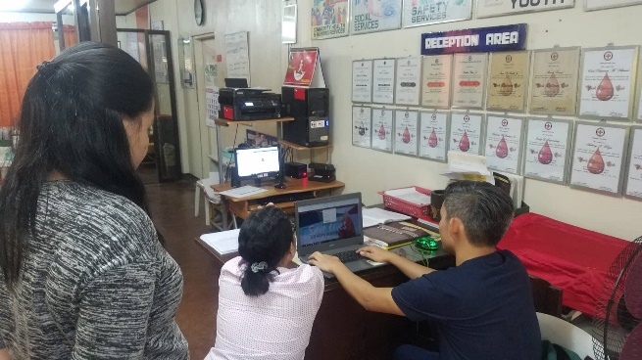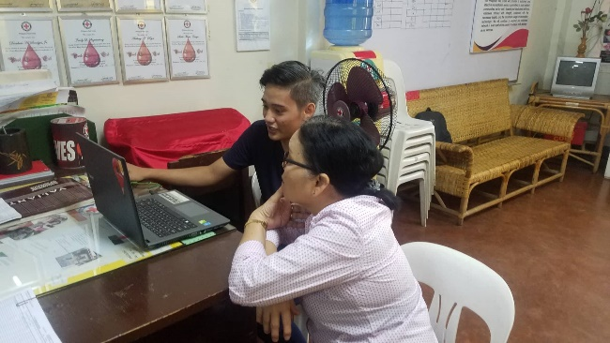Jean Paz Eribal

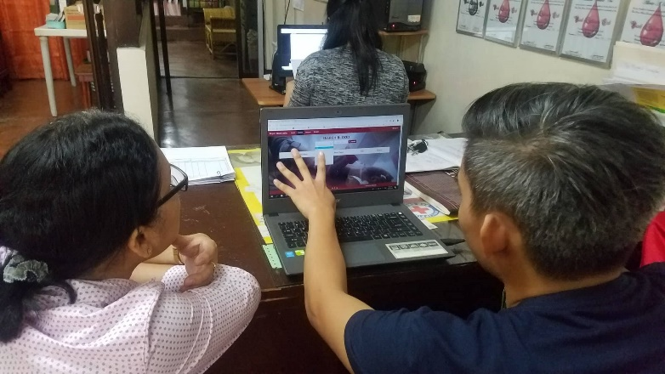

Comments/Suggestions:

The client was satisfied with the system website, the UI was clearly understandable and easy to use. Some functionalities was not finish at the moment but the overall production of the website is beyond expected base on the current process. The client suggested to fix small details on websites client side and on the admin side they suggest to smaller the font so that the text will not consume two line of spaces.

La Salle University First Defence

October 1, 2018 Monday 3 to 5pm LS211

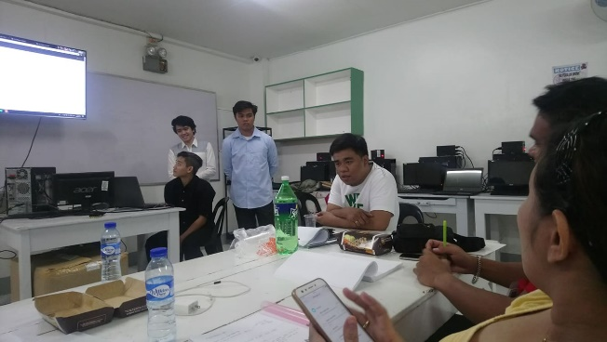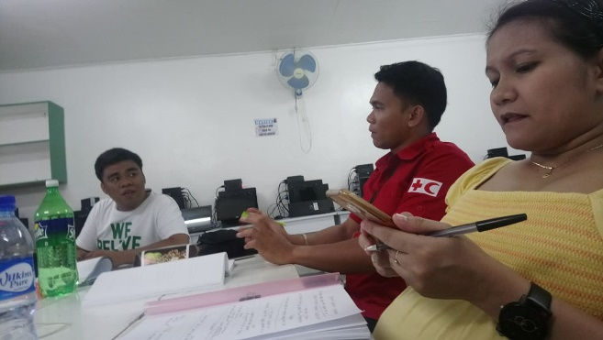Mark Jason Gallo

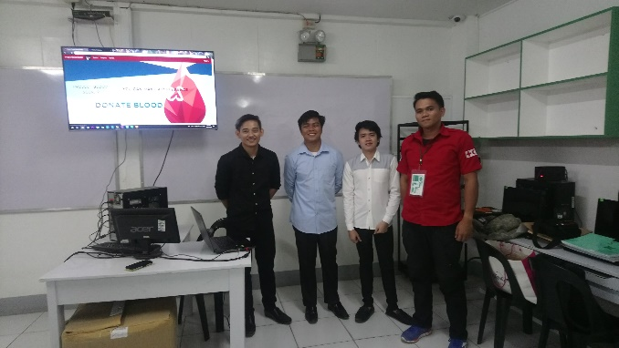

Comments/Suggestions:

The client was not really satisfied with the system website due to some of the process are not met during the presentation. The client state that the system was not fully 100% working base on the process and expectation of system website. The client suggest to finish the lacking processes and modules. The final client and panel decide to represent the system.